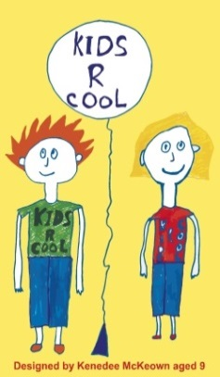
www.jollytots.net
jacki@jollytots.net
Telephone
028 93364630

Day Nursery 4 Victoria Road, Carrickfergus, BT38 7JF

Kids R Cool clubs Sunnylands Primary School, Acorn Integrated Primary School and Oakfield Community Centre.

JOLLYTOTS AND KIDS R COOL (KRC) CHARGING POLICIES

- 1 weeks’ notice for changes. We require in writing (preferably by email) by 5pm on Monday for any change in your registered days/hours effective the following Monday

- No charges for 4 consecutive weeks Off. Registered fees (or fees for hours used if higher) are charged every week unless your child is out for at least 4 consecutive weeks

- Fees continue when your child is not at Jollytots, illness etc. When your child is not in we will charge either their normal registered fees or the average of the last 4 weeks, whichever is the higher

- Pickups charged at 15 minutes. Your registered drop offs and pickups are charged at 15 minutes extra childcare per run based on your normal hourly rate and are charged each week whether you use the service or not (unless the school is closed)

- Pre-school car charged half hourly. We charge half-hourly (on the hour and half hour) on a daily basis for pre-school care, rounded up to the next hour on a weekly basis

- We charge hourly (on the hour) for after-school care.

- School closures charged half hourly. When schools are closed all day, we charge half-hourly (on the hour and half hour) on a daily basis for after-school

- Occasional lateness/earliness of 10 minutes not charged. There is a 10 minute leeway allowed at no charge for the occasional early arrival and late collection
Jollytots NI Ltd is registered in Northern Ireland at 4 Victoria Road, Carrickfergus, BT38 7JF (NI046503)

