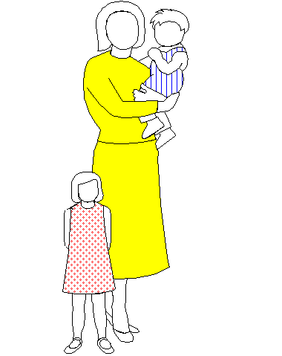
jo l l y t o t s d a y - c a r e n u r s e r y

4 Victoria Road Kids R Cool -Oakfield Kids R Cool -Acorn

Carrickfergus Carrickfergus 110 Victoria Road, Carrickfergus

BT38 7JF BT38 7SP BT38 7JL

93364630 07512159245 07849253700
www.jollytots.net
jacki@jollytots.net
victoria@jollytots.net

Manual Handling Policy

Manual Handling means lifting, lowering, pushing, pulling, carrying, moving, holding or restraining any object, animal or person.

Procedures for managing and monitoring safe manual handling.

Staff are encouraged to use their common sense and not to take unnecessary risks when handling large/heavy objects. When lifting a child or object weighing more than 15 kilos, staff are required to seek assistance.

Manual Handling and correct lifting/back care training will be provided regularly.

It is the responsibility of all staff to follow the procedures below and to assist by identifying manual handling hazards and risks.

Regular checks to monitor use of manual handling at the nursery. Any difficulties noted will then be dealt with immediately.

Managing risks for manual handling.

Identifying risks - discuss issues with staff and check past incidents/accidents records.

Assess risks – how much strain, pressure, stress, weight, force, grip, skill and duration is required for each activity.

A risk assessment will be undertaken for any expectant student or staff member within the setting during their pregnancy.

Control risks – when designing tasks in order to minimise injury, look at changing the way jobs are done, change the layout of the workplace, and change the equipment.

Correct Lifting Procedures.

IF IN DOUBT, DO NOT LIFT!

Staff must never twist while lifting.

When lifting a child or object you should not stretch over and lift, but lean close and raise as close as possible to your body.

When lifting staff must:-

Place their feet apart in a striding position

Keep their breastbone elevated

Bend their knees

Brace their stomach muscles

Hold the child or object close to their body

Move their feet not their spine, to stand up

Prepare to move in a forwards direction.

Staff should transfer heavy items to smaller containers to reduce weight.

Staff should:-

Kneel where possible

Avoid sitting on child sized chairs where possible

Refrain from carrying children on their hip

Lift children with one arm under their buttocks and the other arm under their backs, with the child facing them.

