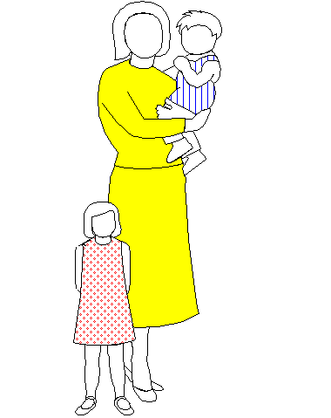
Jo l l y t o t s d a y - c a r e n u r s e r y

4 Victoria Road Oakfield Kids R Cool Acorn Kids R Cool Club

Carrickfergus Carrickfergus 110 Victoria Road, Carrickfergus

BT38 7JF BT38 7SP BT38 7JL

93364630 07512159245 07849253700
www.jollytots.net
jacki@jollytots.net
victoria@jollytots.net

Equal Opportunities Policy

We aim to provide a setting that is free from discrimination, either direct or indirect, by educating our young children to celebrate cultures, religions and races throughout the world. Our children are looked after and educated in a setting which is non-gender stereotypical and promotes positive role models globally in many facets of life, such religion, politics and sport. We will not discriminate on grounds of sex, race, colour, religion, nationality, ethnic or national origins.
We achieve this by:
- Removing barriers to learning so that every child has an equal access to the full range of educational and care aspects of attending Nursery
- Employing staff who receive training and support to ensure their delivery is reflective of current government legislation with regards to Equal Opportunities
- Practitioners being positive role models who treat all within the community of the Nursery with respect, without exception
- Adhering to the Government legislation of 'Every Child Matters' (2003)

Anti-racism
The following procedures have been highlighted for the welfare and safeguarding of all children:
- We have zero tolerance of racism within the setting, and will act swiftly to address any matters that are raised by children, staff or parents. Action will be taken immediately should this be the case
- We promote a global picture and endeavour to make our Nursery welcoming for all. Children's work displayed is reflective of the developmental area of Knowledge and Understanding of the World which promotes cultural awareness
- We use books which allow us to celebrate daily events from different parts of the world which we can include in our planning for the benefit of all children
- We support children to understand the importance of kindness, consideration and fairness to all, and concentrate on pro-social behaviour which works in partnership with behavioural management
The Role of the Staff
Staff are expected to adhere to this policy and to carry out procedures to reduce or eliminate any aspects of equal opportunities that may be encountered by:
- Ensuring that all children are treated fairly and with equal regard
- Ensure that children with disabilities are included fully in activities or that 'reasonable adjustments' are made for them
- To review policies yearly to ensure they are up-to-date and reflective of current practice
- Safeguard children from discrimination, and act on any issues that may arise or seek support from our manager
- To provide toys and activities that are gender non-stereotypical and are fully inclusive
- Ensuring that colour is not accredited to gender
- Plan carefully and use supporting literature which promotes the significant contributions of women, for example, or people from non-European countries
- Dispel Urban myths
The Role of the Manager
The Manager is responsible for equality throughout the setting. Jacki McDowell is expected to:
- Implement and explain the Equal Opportunities Policy to staff and their roles
- To provide training for new staff
- Be involved with the recruitment of new staff with keen regard to the role of the practitioner with a particular emphasis on equal opportunities
- Treat and deal swiftly and effectively with any reports of anti-discriminatory practice throughout the setting

